IQAN Training Recordings

Product Overview

- Hardware Offering
- Software Offering
- Electronics Introduction

Application Development Focus

- IQAN Design 6 Overview
- Interactive Project Build – System Layout
  - New Project – MD4 master
  - Add MC41
  - Connect CAN A of both to diagnostic bus
  - Change MC41 address to 1
  - Connect CAN A of both to master modules together to create a master bus
- Interactive Project Build – LST VIN to control Motor
  - Add VIN for LST
  - Show convenience and select device type as LST
  - Add VIN to MC41
  - Show VIN populated on MC41
  - Change LST VIN to C1:9
  - Add MAC
- Object List
- Interactive Project Build – Implementing a Deadband
  - Add Math channel
    - Name: LST MAC
    - Add multi-vector object
    - Input: LST VIN
    - 4 pts (-100,-100), (-10,0), (10,0), (100,100)
  - Add current output “Motor COUT”
  - Manual setup of mode parameters from data sheet (slide)
    - Min current 180 mA
    - Max current 900 mA
  - Add motor current out to MC41 C1:14/39/55
  - Set PWM Frequency for COUT to 500 Hz
- Qcode
- Interactive Project Build – Qcode example
  - Add Math Channel and Switch to Qcode
    - Name: LST Qcode
    - Result := Vector (LST VIN, (-100,-100), (-10,0), (10,0), (100,100))
  - Compare Old and New
  - Simulate and test
- Exercise – Add LSL VIN MC41 C1:8 / COUT MC41 C1:15/40/56 to control Cylinder using a DMAC channel
  - Add Voltage Input Channel
    - Name: LSL VIN
    - Device Type: IQAN-LSL
    - Drop onto MC41 and check pin assignment
  - Object List Version
    - Add Dual Direction Math Channel
    - Name: LSL DMAC
    - Controlling +/-: Multi-vector object
    - Input: LSL VIN
    - 4 pts (-100,-100), (-10,0), (10,0), (100,100)
  - Qcode Version
    - Add Math Channel
    - Name: Command Qcode
    - Qcode:
command := vector(LSL VIN, (-100, -100), (-10, 0), (10, 0), (100, 100))
Result := command
  - Add Current Output channel
    - Name: Cylinder COUT
    - Input Channel: LST DMAC
    - Default Mode Currents: 180 min, 900 max, both directions
    - Drop onto MC41 and check pin assignment
- Function Groups
- Interactive Project Build – Create Cylinder Function Group
  - Create function group “Cylinder Functions”
  - Drag LSL VIN, LSL DMAC and Cylinder COUT to new group
  - Create function group “Motor Functions”
  - Drag LST VIN, LST MAC, and Motor COUT to new group
- Interactive Project Build – FP2000 to stop cylinder at ends
  - Add 2 DIN inputs
    - Cyl Extend Limit DIN
    - Cyl Retract Limit DIN
  - Drop Cyl Extend Limit DIN on MC41 C1:10
  - Drop Cyl Retract Limit DIN on MC41 C1:24
  - In DMAC for cylinder, add limiting + dual object
    - Input: Cyl Extend Limit DIN
    - Out 1: 0
    - Out 2: 100
  - In DMAC for cylinder, add limiting – dual object
    - Input: Cyl Retract Limit DIN
    - Out 1: 0
    - Out 2: -100
  - Change Command Qcode:
    - 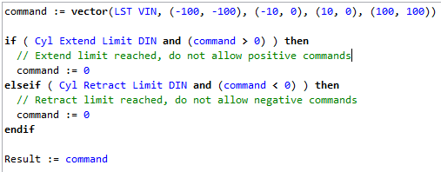
  - Simulate and test
- CAN / J1939 Introduction
- Interactive Project Build – Limit cylinder function based on engine speed
  - Add J1939 device (Engine)
  - Connect CAN B of both master modules to J1939 bus
  - Add JPIN (Manual Method)
    - Name: SPN 190 Engine Speed
    - Unit: RPM
    - Length: 2 Bytes
    - Resolution: 0.125
  - Add JFIN
    - Name: EEC1
    - PGN: 61444 or 0xF004
    - Parameters: SPN 190 Engine Speed
    - Bit offset: 25
  - Add EEC1 to engine
  - Add channels using CAN database (Database Tool Method)
  - Demonstrate timeout warning and fix
  - Add to limiting + in LST DMAC
    - Vector Object
    - Input: SPN 190 Engine Speed
    - In 1: 700
    - Out 1: 20
    - In 2: 1300
    - Out 2: 100
  - Add to limiting – in LST DMAC
    - Vector Object
    - Input: SPN 190 Engine Speed
    - In 1: 700
    - Out 1: -20
    - In 2: 1300
    - Out 2: -100
  - Add Math Channel
    - Name: Limiter Qcode
    - Qcode:
// Qcode to determine command limit based on engine speed
Engine_Speed_Limit := vector(Engine Speed, (700, 20), (1300, 100))
Result := Engine_Speed_Limit
  - Add Math Channel
    - Name: LSL Qcode
    - 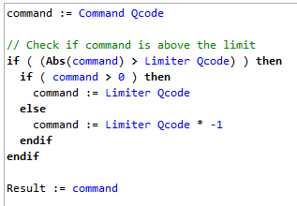
  - Simulate and test
- Interactive Project Build - MD4 User Interface Design
  - Add Display Page “Main Page”
  - Add menu button (Add / Symbol Button / Image Library / menu small)
  - Set action “enter menu system”
  - Simulate and show
  - Add Valve Currents
    - Add / Visual Controls / Label
    - Text: Cylinder Current
    - Alignment: Right
    - Add / Visual Controls / Value
    - Input channel: Cylinder COUT
    - Show: Value and Unit
    - Repeat or copy/paste for Motor Current
  - Add LSL and LST commands
    - Repeat Valve Current steps for LSL and LST commands
  - Add engine speed gauge
    - Visual Controls / Image Gauge / Image Library / Gauge Dial 4 Segment
    - Width: 400
    - Foreground: Blue
  - Modify engine speed gauge properties
    - Input Channel: SPN 190 Engine Speed
    - Range Max Value = 4000
    - Needle Color: Red
    - Needle Length: 160
    - Needle Base Width: 10
    - Needle Tip Width: 0
    - Needle Anchor Color: Red
  - Add RPM labels (0, 1, 2, 3, 4)
  - Add Image library
    - Show import from library
    - Show import custom image
    - Add gauge image
  - Add another engine speed gauge
    - Input Channel: SPN 190 Engine Speed
    - Range min angle: 225
    - Range max angle: 315
    - Range max value: 8000
    - Needle Color = blue
    - Needle Length = 100
    - Needle Width = 5
    - Anchor Color: medium grey
  - Simulate and test
- Interactive Project Build – PID (MC41)
  - Add PID channel “Motor PID”
  - Add FIN channel
    - Name: Motor Speed FIN
    - 172 Hz = 1720 RPM
    - Add to MC41 C1:11
  - Add 4 function parameter channels “I gain”, “P gain”, “D gain”, “Motor PID Command”
  - Add state parameter channel “PID Enable SP”
    - Default State: Disabled
    - Add one state and rename to “Enabled”
  - Add Internal Digital Channel
    - Name: PID Enable IDC
    - Object List:
      - Function Selector: PID Enable SP
      - Disabled: No Objects
      - Enabled: Single object, input true
    - Qcode:
      - Function Selector: PID Enable SP
      - Disabled: No Qcode
      - Enabled: Result := true
  - Link support channels to PID channel “Motor PID”
    - Command: Motor PID Command
    - Feedback: Motor Speed FIN
    - P regulator: P Gain
    - I regulator: I Gain
    - D regulator: D Gain
    - Enable: PID Enable IDC
  - Create adjust group “Motor Parameters”
  - Add “P Gain”, “I Gain”, “D Gain” to adjust group
  - Add “Motor Speed Command” and “PID Enable SP” to adjust items
  - Explain difference between Adjust Groups (Adjustable via IQAN Run and User Interface) and Adjust Items (Adjustable via User Interface only)

- Interactive Project Build – PID (MD4)
  - Add state picker to Main Page
    - Interactive Controls / State Picker
    - Input: PID Enable SP
  - Add Value and Label controls for Motor Speed Command
    - Copy and paste LSL VIN label and value controls
    - Change text to “Motor Speed Command”
    - Change input to Motor PID Command
  - Add Value and Label controls for Motor Speed Feedback
    - Copy and paste LSL VIN label and value controls
    - Change text to “Motor Speed Feedback”
    - Change input to Motor Speed FIN
  - Add slider on interface and tie to Motor Speed Command
    - Interactive Controls / Slider
    - Input: Motor Speed Command
    - Width: 400
- Interactive Project Build – PID (MC41)
  - Adjust min / max values
    - Expand Adjust Items
    - Select Function Parameters category
    - Expand each item to show min / max / step size
    - Motor Speed Command = 0 to 500, step size 10
    - Gains = 0 to 15, step size 0.01
  - Link PID Enable SP to LSL MAC using Function Selector
    - Function Selector: PID Enable SP
    - Disabled: Use existing object list / Qcode
    - Enabled: Motor PID

- Interactive Project Build – Add Video to project
  - Add SV to system
  - Add small video window to main page (160x120 narrow)
  - Add video page to display pages
  - Add video button on main page and link to video page
  - Add large video window to video page (640x480 wide)
  - Add return button on video page and link to main page
- Independent Exercise 1 – Implement the RF50 input as a cylinder speed clamp

- Review Exercise Solutions
  - MC41: Add voltage input channel to Cylinder Functions group
    - Name: RF50 VIN
    - Device Type: RF50
    - Drop onto MC41 and verify connection on C1:25
  - Add math channel to convert degrees to %
    - Name: RF50 MAC
    - Controlling: Vector Object, input = RF50 VIN, points = (-45, 0), (45, 100)
  - Link RF50 MAC to LST DMAC channel
    - Object List:
      - Limiting +: Single object with input RF50 MAC
      - Limiting -: Math object with operator = *, operand 1 = RF50 MAC, operand 2 = -1
    - Qcode:
      - Modify Limiter Qcode channel: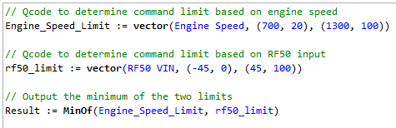
  - MD4: Add value channel to display and link to RF50 VIN
  - Add label
- Independent Exercise 2 – Automatic Cylinder Cycle
- Review Exercise Solutions
  - In the cylinder functions group, add a digital parameter channel
    - Name: Cylinder Mode DP
    - True Text: Auto
    - False Text: Manual
  - Add channel to adjust items
  - On the main page, add a Switch control
    - Input: Cylinder Mode DP
  - On the main page, add a label control next to the switch
    - Text: Cylinder Mode
  - Add an Internal Digital Channel
    - Name: Cyl Extend Latch IDC
    - Activating
      - Single Object
      - Cyl Extend Limit DIN
      - Combination: Latching Or
    - Blocking
      - Single Object
      - Cyl Retract Limit DIN
  - Add a Math Channel
    - Name: Auto Cyl Cmd MAC
    - Controlling
      - Dual Object
      - Input: Cyl Extend Latch IDC
      - Out 1: -100
      - Out 2: 100
  - Modify the LST DMAC channel
    - Single Object: Auto Cyl Cmd MAC
    - Dual Object:
      - Input: Cylinder Mode DP
      - True: Object B
      - False: Object A
  - Add Math Channel
    - Name: Auto Cyl Cmd Qcode
  - 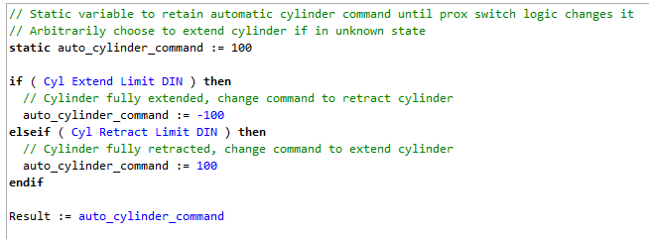
  - Modify LSL Qcode
    - 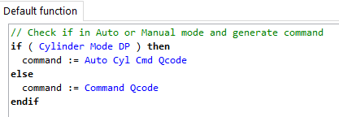
  - Simulate
- Add signal generators in IQAN simulate to toggle prox switch inputs
  - Add Cyl Extend Limit DIN and Cyl Retract Limit DIN to Simulation Group
  - Configure Cyl Extend Limit DIN:
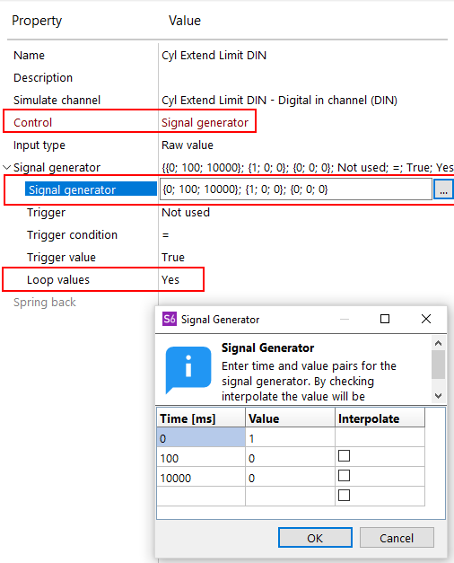
  - Configure Cyl Retract Limit DIN:
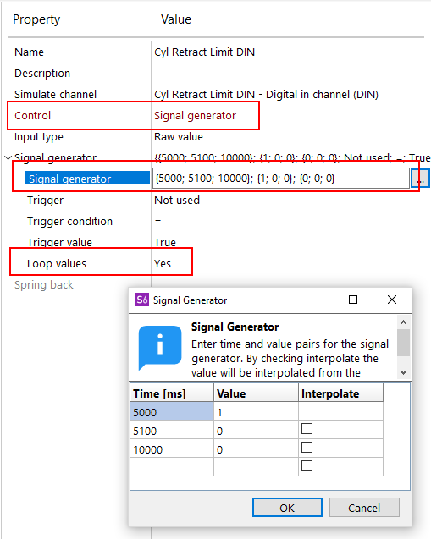

Diagnostic / Technician Focus

- IQAN Design Diagnostics and Additional Features
  - Measure Groups
    - Create Cylinder Functions Group
    - Drop in some cylinder related channels
  - Logs
    - Create Statistics Log
    - Engine Speed > 2000 Counter
  - Component Navigator
  - Multimeter
  - Project Properties
  - Project Statistics
  - Comments
  - Languages
  - External Functions
    - Create external function with the Motor Functions function group
    - Add adjustable channels to adjust items
    - When added back to main program, add gains to adjust group
- IQAN Security Features
  - User Levels
    - Apply user level to adjust group
    - Demo in IQAN run
  - PIN Codes
  - Application Passwords
  - Function Group Passwords
  - Safe Passwords
- IQAN Resources and Connectivity
  - Help Box
  - PDF documentation
  - Solution Library
  - Forum
  - IQAN Store
  - Connectivity

- IQAN Run Overview

